  - student curriculum handbook-2017

Takemusu aikido - maryland
The curriculum is designed to guide students through a steady educational transition from 6th Kyu to 1st Dan.
The times between grades are minimums since the last grade was achieved.
Students will only be able to take a test at their Instructor’s discretion.

Takemusu aikido - maryland
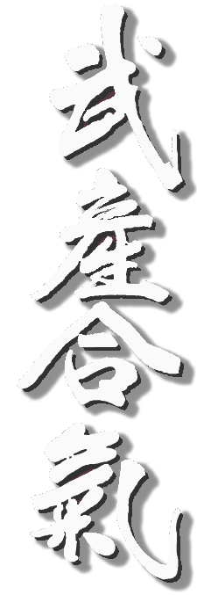

Dojo Etiquette
Proper observance of etiquette is as much a part of your training as is learning techniques. Please take the following guidelines seriously.
- When entering or leaving the dojo, it is proper to bow in the direction of O Sensei's picture, the kamiza, or the front of the dojo. You should also bow when entering or leaving the mat.
- No shoes on the mat.
- Be on time for class. If you do happen to arrive late, sit quietly in seiza on the edge of the mat until the instructor grants permission to join practice.
- If you should have to leave the mat or dojo for any reason during class, approach the instructor and ask permission.
- Avoid sitting on the mat with your back to the picture of O Sensei or the kamiza. Also, do not lean against the walls or sit with your legs stretched out. (Either sit in seiza or cross- legged.)
- Remove watches, rings and other jewelry before practice.
- Do not bring food, gum, or beverages with you into the dojo.
- Please keep your finger and toe nails cut short.
- Please keep talking during class to a minimum. What conversation there is should be restricted to one topic -- Aikido.
- Carry out the directives of the instructor PROMPTLY. Do not keep the rest of the class waiting for you!
- Do not engage in rough-housing or needless contests of strength during class.
- Keep your training uniform clean, in good shape, and free of offensive odors.
- Please pay your membership dues promptly. If, for any reason, you are unable to pay your dues on time, talk with the person in charge of dues collection. Sometimes special rates are available for those experiencing financial hardship.
- Do not change your clothes on the mat.
- Remember that you are here to learn, and not to gratify your ego. An attitude of receptivity and humility (though not obsequiousness) is therefore advised.
- Preserve common-sense standards of decency and respect at all times.

NOTE TO STUDENTS about testing

Be sure you have the required number of practice days before applying for an examination.

Minimum age for 1st Kyu is 14 years.

An examination shall be taken at the dojo where you normally practice.

As a rule partners (uke) in an examination should be of the same rank.

Continue doing the same technique, left and right, ura and omote, until the examiner says "Stop".

6th Kyu
White Belt

Students must have trained for a minimum of 2 months.

Technique | Attack | Direction/Option | Position
Tai no henko | Katatedori | Kihon & Kinonagre | Tachiwaza
Kokyu ho | Morotedori |  | Tachiwaza
Ikkyo | Shomenuchi | Omote & Ura | Tachiwaza
Kotegaeshi | Kosadori |  | Tachiwaza
Ukemi |  | Mae & Ushiro | Suwariwaza
Shikko
Kokyu Dosa | Ryotedori | Kihon | Suwariwaza

5th Kyu
Yellow Belt
Students must have trained for a minimum of 2 months from 6th Kyu.
30 days of practice

Technique | Attack | Direction/Option | Position
Tai no henko | Katatedori | Kihon & Kinonagre | Tachiwaza
Kokyu ho | Morotedori |  | Tachiwaza
Ikkyo | Shomenuchi | Omote & Ura | Tachi & Suwariwaza
 | Katatedori | Omote & Ura | Tachiwaza
 | Ryotedori | Omote & Ura | Tachiwaza
Nikkyo | Shomenuchi | Omote & Ura | Tachiwaza
 | Katatedori | Omote & Ura | Tachiwaza
 | Ryotedori | Omote & Ura | Tachiwaza
Kotegaeshi | Kosadori |  | Tachiwaza
 | Tsuki |  | Tachiwaza
Shihonage | Katatedori | Omote & Ura | Tachiwaza
 | Ryotedori | Omote & Ura | Tachiwaza
Irimi Nage | Shomenuchi |  | Tachiwaza
Kokyu Dosa | Ryotedori |  | Suwariwaza
Weapons
Ken | Suburi | 1 to 7
 | Happogiri | 8 directions
Jo | Suburi | 1 to 10

4th Kyu
Orange Belt
Students must have trained for a minimum of 4 months since 5th Kyu
40 days of practice after obtaining 5th Kyu
Technique | Attack | Direction/Option | Position
Tai no henko | Katatedori | Kihon & Kinonagre | Tachiwaza
Kokyu ho | Morotedori |  | Tachiwaza
 | Katatedori |  | Tachiwaza
Ikkyo | Katatedori | Omote & Ura | Suwariwaza
 | Ryotedori | Omote & Ura | Suwariwaza
 | Katadori | Omote & Ura | Tachiwaza
 | Kosadori | Omote & Ura | Tachiwaza
 | Shomenuchi | Omote & Ura | Tachiwaza
Nikkyo | Shomenuchi | Omote & Ura | Suwariwaza
 | Katadori | Omote & Ura | Tachiwaza
Sankyo | Shomenuchi | Omote & Ura | Tachiwaza
 | Katatedori | Omote & Ura | Tachiwaza
 | Ryotedori | Omote & Ura | Tachiwaza
Kotegaeshi | Shomenuchi |  | Tachiwaza
Shihonage | Ryotedori | Omote & Ura | Tachiwaza
 | Shomenuchi | Omote & Ura | Tachiwaza
 | Yokomenuchi | Omote & Ura | Tachiwaza
Iriminage | Shomenuchi |  | Tachiwaza
Kaitenage | Katatedori | Soto & Uchi Mawari | Tachiwaza
 | Ryotedori | Soto & Uchi Mawari | Tachiwaza
Weapons
Ken | Awase | Migi, Hidari, Go & Shichi
Jo | Suburi | 1 to 20
 | 13 Kata | All

3rd Kyu
Green Belt
Students must have trained for a minimum of 6 months since 4th kyu
50 days of practice after obtaining 4th Kyu
Technique | Attack | Direction/Option | Position
Ikkyo | Shomenuchi | Omote & Ura | Tachi & Suwariwaza
 | Ryotedori | Omote & Ura | Suwariwaza
 | Yokomenuchi | Omote & Ura | Tachiwaza
 | Mundadori | Omote & Ura | Tachiwaza
Nikkyo | Shomenuchi | Omote & Ura | Tachi & Suwariwaza
 | Katatedori | Omote & Ura | Suwariwaza
 | Ryotedori | Omote & Ura | Suwariwaza
 | Kosadori | Omote & Ura | Tachiwaza
 | Munadori | Omote & Ura | Tachiwaza
Sankyo | Shomenuchi | Omote & Ura | Tachi & Suwariwaza
 | Katatedori | Omote & Ura | Suwariwaza
 | Ryotedori | Omote & Ura | Suwariwaza
 | Katadori | Omote & Ura | Tachiwaza
Yonkyo | Shomenuchi | Omote & Ura | Tachi & Suwariwaza
 | Katatedori | Omote & Ura | Tachiwaza
 | Ryotedori | Omote & Ura | Tachiwaza
Kotegaeshi | Shomenuchi |  | Hanmihandachi
 | Tsuki |  | Hanmihandachi
 | Katatedori |  | Tachiwaza
Shihonage | Katatedori |  | Tachiwaza
 | Ryotedori | Omote | Hanmihandachi
 | Yokomenuchi | Omote & Ura | Hanmihandachi
Iriminage | Katatedori | Jodan, Chudan, Gedan | Tachiwaza
 | Shomenuchi |  | Tachiwaza
 | Ryotedori |  | Tachiwaza
 | Tsuki |  | Tachiwaza
Kaitenage | Shomenuchi |  | Tachiwaza
 | Tsuki |  | Tachiwaza
 | Katatedori | Soto & Uchi Mawari | Hanmihandachi
 | Ryotedori |  | Tachiwaza
Koshinage | Katatedori |  | Tachiwaza
 | Ryotedori |  | Tachiwaza
 | Tsuki |  | Tachiwaza
Tenchinage | Ryotedori |  | Tachiwaza
Kokyu Nage | Katatedori | X3 | Tachiwaza
Ukemi | High Fall (at instructor’s discretion; factor student ability/age)
Kokyu Dosa | Ryotedori | Hands held full strength | Suwariwaza
Weapons
Ken | Kumi tachi
 | Ki musubi no tachi
Jo | 31 Kata | All
 | 31 Kumijo | 1-3, 4-6, 9-11

2nd Kyu
Blue Belt
Students must have trained for a minimum of 9 months since 3rd kyu
50 days of practice after obtaining 3rd Kyu
Technique | Attack | Direction/Option | Position
Ikkyo | Shomenuchi | Omote & Ura | Tachiwaza & Suwariwaza
 | Katadori | Omote & Ura | Tachiwaza & Suwariwaza
 | Yokomenuchi | Omote & Ura | Suwariwaza
 | Morotedori | Omote & Ura | Tachiwaza
 | Tsuki | Omote & Ura | Tachiwaza
 | Ushiro Ryotedori | Omote & Ura | Tachiwaza
Nikkyo | Shomenuchi | Omote & Ura | Tachiwaza & Suwariwaza
 | Katadori | Omote & Ura | Tachiwaza & Suwariwaza
 | Yokomenuchi | Omote & Ura | Tachiwaza
 | Morotedori | Omote & Ura | Tachiwaza
 | Tsuki | Omote & Ura | Tachiwaza
 | Ushiro Ryotedori | Omote & Ura | Tachiwaza
Sankyo | Shomenuchi | Omote & Ura | Tachiwaza & Suwariwaza
 | Katadori | Omote & Ura | Tachiwaza & Suwariwaza
 | Yokomenuchi | Omote & Ura | Tachiwaza
 | Munedori | Omote & Ura | Tachiwaza
Yonkyo | Shomenuchi | Omote & Ura | Tachiwaza & Suwariwaza
 | Katadori | Omote & Ura | Tachiwaza & Suwariwaza
 | Katatedori | Omote & Ura | Suwariwaza
 | Ryotedori | Omote & Ura | Suwariwaza
 | Katadori | Omote & Ura | Suwariwaza
 | Yokomenuchi | Omote & Ura | Tachiwaza
Gokkyo | Yokomenuchi | Ura | Tachiwaza
Kotegaeshi | Katadori |  | Tachiwaza
 | Ushiro Ryotedori |  | Tachiwaza
Shihonage | Katadori | Omote & Ura | Tachiwaza
 | Tsuki | Omote & Ura | Tachiwaza
 | Katatedori | Omote & Ura | Hanmihandachi
Iriminage | Katadori | Omote & Ura | Tachiwaza
 | Yokomenuchi |  | Tachiwaza
 | Tsuki |  | Hanmihandachi
 | Shomenuchi |  | Hanmihandachi
Kaitenage | Tsuki |  | Hanmihandachi
 | Shomenuchi |  | Hanmihandachi
Tenchinage | Katatedori |  | Tachiwaza
 | Ryotedori |  | Tachiwaza
Koshinage | Shomenuchi | X2 | Tachiwaza
 | Ushiro Ryotedor |  | Tachiwaza
Kokyu Nage | Shomenuchi |  | Tachiwaza
 | Katadori |  | Tachiwaza
 | Morotedori |  | Tachiwaza
 | Ushiro Ryotedori |  | Tachiwaza
Kokyu Dosa | Ryotedori | Hands pinned to knees | Suwariwaza
Weapons
Ken | Kumi Tachi | 1 to 5
Jo | 31 Kumi Tachi | 13-17, 18-22, 23-27, 28-31
Tanto | Tsuki | Kotegaeshi
 | Yokomenuchi | Gokkyo
 | Knife at center of back

1st Kyu
Brown Belt
Students must have trained for a minimum of 12 months since 2ndkyu
60 days of practice after obtaining 2nd Kyu
Technique | Attack | Direction/Option | Position
Ikkyo | Shomenuchi | Omote & Ura | Tachi & Suwariwaza
 | Katadori | Omote & Ura | Tachi & Suwariwaza
 | Yokomenuchi | Omote & Ura | Tachi & Suwariwaza
 | Ryotedori | Omote & Ura | Hanmihandachi
 | Ushiro Ryokatadori | Omote & Ura | Tachiwaza
 | Ushiro Ryotedori | Omote & Ura | Tachiwaza
Nikkyo | Shomenuchi | Omote & Ura | Tachi & Suwariwaza
 | Katadori | Omote & Ura | Tachi & Suwariwaza
 | Yokomenuchi | Omote & Ura | Tachi & Suwariwaza
 | Ryotedori | Omote & Ura | Hanmihandachi
 | Ushiro Ryotedori | Omote & Ura | Tachiwaza
 | Ushiro Ryokatadori | Omote & Ura | Tachiwaza
Sankyo | Shomenuchi | Omote & Ura | Tachi & Suwariwaza
 | Katadori | Omote & Ura | Tachi & Suwariwaza
 | Yokomenuchi | Omote & Ura | Tachi & Suwariwaza
 | Morotedori | Omote & Ura | Suwariwaza
 | Tsuki | Omote & Ura | Suwariwaza
 | Ushiro Ryotedori | Omote & Ura | Tachiwaza
Yonkyo | Shomenuchi | Omote & Ura | Tachi & Suwariwaza
 | Katadori | Omote & Ura | Tachi & Suwariwaza
 | Yokomenuchi | Omote & Ura | Tachi & Suwariwaza
 | Munadori | Omote & Ura | Tachiwaza
 | Morotedori | Omote & Ura | Tachiwaza
 | Tsuki | Omote & Ura | Tachiwaza
 | Ushiro Ryotedori | Omote & Ura | Tachiwaza
Gokkyo | Yokomenuchi | Ura | Suwariwaza
 | Tsuki | Ura | Tachiwaza
Rokkyo | Tsuki | Ura | Tachiwaza
 | Shomenuchi | Ura | Tachiwaza
Kotegaeshi | Yokomenuchi |  | Tachiwaza
 | Munadori |  | Tachiwaza
 | Ushiro Ryotedori |  | Tachiwaza
Shihonage | Munadori | Omote & Ura | Tachiwaza
 | Morotedori | Omote & Ura | Tachiwaza
 | Katatedori | Omote & Ura | Tachiwaza & Hanmihandachi
 | Ryotedori | Omote & Ura | Tachiwaza & Hanmihandachi
Iriminage | Katatedori |  | Suwariwaza
 | Shomenuchi |  | Suwariwaza
 | Morotedori |  | Tachiwaza
 | Tsuki |  | Tachiwaza
Kaitenage | Katadori |  | Tachiwaza
 | Munadori |  | Tachiwaza
Tenchinage | Ryotedori |  | Tachiwaza
Koshinage | Morotedori |  | Tachiwaza
 | Katadori |  | Tachiwaza
 | Yokomenuchi |  | Tachiwaza
Jujinage | Munadori |  | Tachiwaza
 | Tsuki |  | Tachiwaza
 | Ushiro Ryotedori |  | Tachiwaza
Kokyu Nage | Yokomenuchi |  | Tachiwaza
Jiyuwaza | Katatedori | (aka Randori) | Tachi & Suwariwaza
 | Tsuki |  | Tachi & Suwariwaza
 | Morotedori |  | Tachi & Suwariwaza
Kokyu Dosa | Hijidori | Both elbows held | Suwariwaza
Weapons
Ken | Tachi Dori | 3
Jo | Jo Dori | 3
 | Jo Nage | 3
 | 13 Jo Awase | All
 | 31 Kumijo | All
 | 10 Kumijo | 1 to 3
Tanto | Tanto Dori | Any 4

ShoDan
1st Degree Black Belt
Students must have trained for a minimum of 12 months since 1st kyu
70 days of practice after obtaining 1st Kyu
Students must attend two sanctioned seminars in the 12 months prior to the test at least one of which is taught by someone other than regular instructor.

All techniques to be performed in kihon (vice ki no nagare) unless otherwise instructed by the examiner.

Unarmed techniques: sitting, sitting v.s. standing, standing techniques for strikes, thrusts, all forms of grasping (shoulders, elbows, collar, wrists and hands; all techniques from the rear)

Weapons
Technique | Attack | Direction/Option | Position
Ken | Kumi Tachi | All
 | Tachi Dori | 5
Jo | Jo Dori | 5
 | 10 Kumi Jo | 1 to 5
Tanto | Tanto Dori | Tsuki
 |  | Yokomenuchi
 |  | Kubishime
 |  | Knife held front
 |  | Knife held back
 |  | Slash attack
Jiyuwaza | 40-50 seconds | 2 attackers | Tachiwaza
Kokyu Dosa | 3 simple attacks |  | Suwariwaza

  - Aikido Terminology
Striking:
Atemi |  | Strike to a vital point
Chudan-zuki |  | A punch to the abdominal region
Gedan-zuki |  | Downward punch
Gyaku-uchi |  | Any reverse strike
Gyaku-zuki |  | Punching with the rear hand
Jodan-zuki |  | Upper strike
Kaeshi-zuki |  | Counter thrust
Katate-uchi |  | One-handed strike
Men-uchi |  | Strike to head
Mune tsuki |  | Thrust toward knot on obi
Oi-zuki |  | A step-punch
Shomen uchi |  | Overhead strike to the head.
Tsuki |  | In Aikido, usually a Chudan Oi-zuki
Uchi |  | Inside; strike
Yokomen uchi |  | Diagonal strike to the side of the head.
Yoko-uchi |  | A sideward strike
Holds:
Gyakute-dori |  | To grasp with one's hand reversed; to grasp and opponents right wrist with your left hand
Katate dori |  | One hand holding one hand.
Kosadori |  | hand grab (katatedori ai-hanmi)
Morote dori |  | Two hands holding one hand.
Kata dori |  | Shoulder hold
Ryokata dori |  | Grabbing both shoulders.
Ryote dori |  | Two hands holding two hands.
Mune dori |  | One or two hand lapel hold.
Hiji dori |  | Elbow grab
Sode dori |  | Sleeve grab
Ushiro eri-dori |  | Neck grab from the back (usually the collar :-)
Ushiro tekubi dori |  | Wrist grab from the back.
Ushiro ryote dori |  | As above from the back.
Ushiro ryokata dori |  | As above from the back.
Ushiro kubi shime |  | Rear choke.
Anatomy:
Hara |  | The abdomen, stomach
Abara |  | The ribs
Ago |  | Jaw
Ashi |  | Leg
Ashikubi |  | Ankle
Atama |  | Head
Chototsu |  | Atemi point between the eyes
Daitai |  | The thigh
Denko |  | Atemi point at the floating ribs
Dokko |  | Pressure point behind the ear
Empi |  | The elbow
Eri |  | Lapel; collar
Fukuto |  | Atemi point just above inside of knee
Ganmen |  | The face
Gekon |  | Pressure point below lower lip
Gokoku |  | Pressure point in fleshy area between thumb and forefinger
Haishu |  | Back of the hand
Haito |  | Ridgehand
Haiwan |  | Back of forearm
Hiji |  | Elbow
Hiji-zume |  | Atemi point on inside of elbow
Hitai |  | Forehead
Ippon-ken |  | An one-knuckle fist
Jintai |  | The body
Jinkai-kyusho |  | Vital points on the human body
Juizo |  | The kidney area
Junchu |  | Atemi point on the upper lip
Kakuto |  | Back of the wrist (for a strike)
Kashi |  | Legs
Katate |  | One hand
Kenkokotsu |  | Shoulder blades
Kikan |  | Trachea
Koko |  | Area between thumb and forefinger
Kote |  | Wrist
Kubi |  | Neck
Kubi-naka |  | Atemi point at base of skull
Kyusho |  | Vital point on body
Mata |  | The thigh; the groin
Men |  | Head
Mikazuki |  | Atemi at corner of jaw
Mimi |  | Ears
Morote |  | Both hands
Mukozune |  | Atemi point in middle of shin
Mune |  | Chest
Murasame |  | Pressure points on each side of neck behind collar bone
Naike |  | Pressure point on inside of ankle
Nukite |  | Ends of stiffened fingers
Seika-tanden |  | Lower abdomen
Seiken |  | Front of fist
Seikichu |  | The spine
Senaka |  | The back of the body
Shintai |  | The body
Shita hara |  | Lower abdomen
Shomen |  | Face
Shuhai |  | Back of the hand
Shuto |  | Edge of hand
Sode |  | Sleeve
Sokei |  | Groin
Sokuso |  | Tips of toes (for kicking)
Sokutei |  | Bottom of heel
Sokuto |  | Edge of foot
Tanden |  | Abdomen
Tegatana |  | The arm as sword
Teisho |  | Heel of the hand
Tekubi |  | Wrist
Te-no-hira |  | Palm of hand
Tento |  | Atemi point on top of head
Tettsui |  | Hammer fist
Te-ura |  | Inside of wrist
Ude |  | The arm
Uraken |  | Back of fist
Waki |  | Side; armpit
Wakikage |  | Atemi point in armpit
Yokomen |  | Side of the head
Yubi |  | Finger
Zengaku |  | Forehead
Zenshin |  | The entire body
Zenwan |  | Forearm
Commands in the dojo:
Ato |  | Move back
Hajime |  | Start
Hayaku |  | Quickly
Kiyotsukete |  | Be careful
Koutai |  | Change
Mate |  | Wait
Mawatte |  | Turn around
Mokuso |  | Close the eyes, meditation
Suwatte |  | Sit down
Tatte |  | Raise
Yame |  | Stop
Yoi |  | Ready
Yukuri |  | Slow
Yuru yaka ni |  | Smooth
Shinzen ni rei |  | Bow to shrine
Sensei ni rei |  | Bow to sensei
Joseki ni rei |  | Bow to the high section of the dojo
Kamiza ni rei |  | Bow to kamiza (gods)
Otagai ni rei |  | Bow to each other
Rei |  | Bow
Words:
Arigato |  | Thank you (informal)
Domo |  | Thanks (informal)
Domo arigato |  | Thank you (formal)
Domo arigato gozaimasu |  | Thank you very much (very formal) (for something that is happening)
Domo arigato gozaimas'ta |  | Thank you very much (very formal) (for something that has just ended)
Dozo |  | Please go ahead
Gomen nasai |  | Excuse me, I'm sorry
Onegaishimasu |  | Please (when asking for something, usually as in Please lets practice together)
Sumimasen |  | Excuse me (to attract attention)
Hai |  | Yes
Iie |  | No
Wakarimasu |  | I understand
Directions:
Mae |  | Forward
Migi |  | Right
Hidari |  | Left
Ushiro |  | Rearward, behind
Omote |  | Front
Ura |  | Back
Uchi |  | Inside
Soto |  | Outside
Jodan |  | High
Chudan |  | Middle
Gedan |  | Low
Chokkaku |  | Right angles
Heiko |  | Parallel
Massugu |  | Straight ahead
Naname |  | Diagonal
Otoshi |  | Dropping
Shomen |  | Straight ahead
Ue |  | Up
Yoko |  | Horizontal, to the side
Asoko |  | Over there
Gyaku |  | Reverse, opposite, inverted
Hantai |  | The other way around
Kiku |  | Lower
Komi |  | Coming close or drawing near.
Soko |  | There, that position
Hantai-ni |  | In the opposite direction
Happo |  | The eight sides; in all directions
Ichimonji |  | A straight line
Chokusen |  | A straight line
Naka |  | Center
Naka ni |  | To the center
Waki |  | Side; armpit
Zenpo |  | Front
General:
Uchi deshi |  | A live-in student
Budo |  | Martial way
Aikido |  | The way of harmony with ki
Dojo |  | Lit. "way place"
Zanshin |  | lit. "remaining spirit", balanced and aware state
Kiai |  | A shout delivered for the purpose of focussing all of one's energy
Satori |  | Enlightenment
Misogi |  | purification ceremony
Musubi |  | Ending, conclusion, union
Shugyo |  | Training, pursuit of knowledge
Tatami |  | Mat
Uke |  | Receiver of the technique (attacker)
Nage |  | Doer of the technique (defender)
Bokken |  | Wooden sword
Bokuto |  | Wooden sword
Jo |  | Short staff (~130 cm length)
Shinai |  | Bamboo sword
Enten-jizui |  | Moving and turning freely
Genshin |  | Intuition
Giri |  | Duty; What you have to do
Happo-baraki |  | To be totally aware of ones surroundings
Hiki |  | Pull; tug
Hineri |  | A twist
Hito-e-mi |  | Blending with motion of attack
Ido |  | Movement
Idori |  | Techniques practiced from seiza
Ikki-ni |  | In one breath; instantly
Ima |  | Now
Irimi |  | Entering
Kaiten |  | Rotation
Kaiten-juki |  | The axis of rotation of a technique
Kan |  | Intuition
Karame |  | To tie up; to arrest
Karami |  | An entanglement
Karui-geiko |  | Light, easy practice
Kashaki-uchi |  | Continuous attack
Kihon |  | Fundamental
Kokoro |  | Spirit, will, heart, intuition, mood
Kokoro-gamae |  | Mental attitude
Kokutsu |  | Backward leaning
Koryu |  | Old style
Kujiki |  | Strain
Kushin |  | Springing in to attack
Kusshinuke |  | To dodge an attack
Maai |  | Combat engagement distance
Mae-no-sen |  | Taking the initiative; Attacking the instant your opponent thinks about it
Maki |  | Wrapped around
Mawashi |  | A turn; a rotation
Moku roku |  | A catalog of techniques
Mokuso |  | Meditation
Munen mushin |  | Striking without conscience
Munen muso |  | The goal of zazen
Nagashi |  | Flow
Ninjo |  | What you have to do
No |  | Possessive particle of speech
Nobashi |  | Stretched out
Nuki |  | Pull
Oji |  | A response
Osae |  | Press; push; to immobolize
Randori |  | Free style
Reigi |  | Etiquette; also reishiki
Renshu |  | Hard work on basics
Ritsurei |  | A standing bow
Sabaki |  | Body motion
Saho |  | The left direction
Sankaku |  | Triangle
Seme-guchi |  | An opening for an attack
Semete |  | Attacker
Sen |  | The initiative; also 1000
Senjutsu |  | Tactics
Sen-no-sen |  | Seizing initiative just as opponents initiates attack
Sente |  | The person who takes the initiative
Shi |  | A (samurai) person
Shiki |  | Ceremony, style, form
Shikko |  | On one's knees
Shinshin |  | Mind and body
Shinshin shugyo |  | Mind and body training
Shinshin toitsu |  | Mind and body unified
Shita |  | Down
Shita-no |  | Of the lower part
Shizoku |  | Safe spot
Sho |  | Small
Shoshin |  | Beginners mind
Shuchu |  | Concentration
Shugeki |  | Attack
Sudori |  | Momentum
Sukui |  | Scooping
Tai-atari |  | Body contact
Tai-chikara |  | External power (muscle)
Taisabaki |  | Body motion
Taijutsu |  | Body art
Tai-no-henko |  | Reversing the body's position
Tanin-geiko |  | Practicing with multiple attackers
Taoshi |  | To tip over
Tateki |  | Multiple attackers
Tateki-geiko |  | Practicing with multiple attackers
Tateki-uchi |  | Fighting with multiple attackers
Tenkan |  | Pivot
Tsukami |  | To seize (and immobilize)
Uchima |  | Distance where you can strike by taking a single step
Uchimata |  | The inside of the throw
Uchite |  | The attacker
Uki |  | Floating
Yo |  | Positive principle of nature
Yoko-furumi |  | Sideward motion
Yumi |  | A bow (archery)
Zentai |  | Total
Fukushiki-kokyu |  | Abdominal breathing
Ibuki |  | A breathing method featuring a long exhalation, followed by a short cough to clear lungs
In-ibuki |  | Internal (quiet) breathing
Nogare |  | Breathing method featuring long exhalation with sharp gasp
Ritsuzen |  | Standing meditiation
Yo-inbuki |  | External (power) breathing
Postures:
Hanmi |  | Half forward stance.
Hitoemi |  | Equal stance, feet parallel forward
Iai goshi |  | Hips lowered, stable position.
Iai hiza, Tate hiza |  | Kneeling on one calf.
Kamae |  | Posture, stance.
Kiza |  | Kneeling, but up on the toes.
Seiza |  | Kneeling on both calves.
Tachi |  | Standing.
Chudan |  | Middle kamae, sword in middle, seigan is a chudan gamae.
Gedan |  | Lower level, sword pointed down.
Hasso gamae |  | Figure 8 stance, sword by side of head. Usually hasso hidari, sword on right, left foot forward.
Jodan |  | Upper level, sword above head. Usually hidari jodan, left foot forward.
Karuma |  | like waki gamae, blade horizontal.
Kasumi |  | Arms crossed over to hide technique (mountain mist).
Kongo |  | Blade vertical in front of face.
Seigan |  | Natural step, fundamental kamae.
Waki gamae |  | Sword pointed down and back, for a sutemi (sacrifice) waza. Usually sword on right side (migi waki gamae), left foot forward. Other purpose - hiding length of sword, especially in case of a broken one.
Principles:
Ikkyo |  | 1. principle = oshi taoshi, ude osae
Nikyo |  | 2. principle = kote mawashi, kotemaki
Sankyo |  | 3. principle = kote hineri, shibori-kime
Yonkyo |  | 4. principle = tekubi osae
Gokyo |  | 5. principle = kuji-osae
Rokkyo |  | 6. principle = hiji-kime-osae or waki-katame or ude-hishigi.
Nanakyo |  | 7. principle = Yonkyo applied to back of wrist
Hakyo |  | 8. principle = kote-ori-kakae-kimi, kuji-dori = Nikyo in which his elbow is in your armpit and his hand is pulled forward; Pinning their hand with your foot
Kukyo |  | 9. principle = Inverted nanakyo
Throws:
Irimi nage |  | Entering throw ("20 year technique")
Juji nage, juji garami |  | Arm entwining throw ("No. 10 throw", since the arms form the japanese sign for 10 "+". arms crossed, elbows locked)
Kaiten nage |  | Rotary throw. uchi-kaiten nage and soto-kaiten nage (inside and outside)
Kokyu ho |  | morotetori kokyu nage or ryotemochi kokynage ude-oroshi irimi
Kokyu nage |  | Breath throw (There are a zillion of these in Aikido. Most of them just variations of the basic techniques)
Koshi nage |  | Hip throw
Kote gaeshi |  | Wrist turn-out
Shiho nage |  | Four direction throw
Tenchi nage |  | Heaven and earth throw
Aiki otoshi |  | entering more deeply and picking up uke's off-side leg
Maki otoshi |  | nage ends up down on one knee, having thrown uke over nage's shoulder
Sumi gaeshi |  | corner throw
Sumi otoshi |  | Corner drop
Tai-atari uchi otoshi |  | from yokomen-uchi, entering and blocking.,uke gets thrown backwards
Ushiro udoroshi |  | pull down from behind
Kokyu dosa |  | Breath-power movement (from seiza)
Ganseki otoshi |  | Arm bar with elbow braced over shoulder
Katagatame |  | A variation of Kaiten nage where you lock your opponents shoulder and bring him directly to the ground in a lock
Ranks and titles:
Kohai |  | Junior student
Sempai |  | Senior student
Sensei |  | Instructor
Shihan |  | A senior teacher, properly used within the school only, when outside, use sensei
Kyu |  | Student grade, from 10 up to 1, the highest: jukyu, kukyu, hachikyu, nanakyu, rokyu , gokyu , yonkyu , sankyu , nikkyu , ikkyu
Dan |  | More advanced grades, from 1 to 10: shodan , nidan , sandan , yondan , godan , rokudan , nanadan , hachidan , kudan , judan
Yudansha |  | Members with dan grades
Mudansha |  | Members with kyu grades
Hanshi |  | Highest title from ZNKR, must be 55 or older and 8 dan.
Kyoshi |  | Middle title from ZNKR, must be 7th dan.
Renshi |  | Title bestowed from ZNKR in addition to Dan ranks.
Soke |  | Head of style (actually head of family, unifier of gods and lineage)
Doshu |  | Head of the way (currently Moriteru Ueshiba, grandson of O Sensei)
Kaicho |  | "Owner" of school (organization) eg. Sei Do Kai
Kancho |  | "Owner" of school (building, hall) eg. Yugen Kan
Dojo-cho |  | "Leader" of a dojo
O Sensei |  | Great Teacher (Ueshiba, Morihei)
Techniques:
Ukemi |  | Lit. "receiving with the body"
Kumitachi |  | Sword partnership practice
Kumijo |  | Staff partnership practices
Tachi dori |  | Sword takeaways
Tanto dori |  | Knife takeaways
Atemi-waza |  | Techniques to strike a vital point
Hanashi-waza |  | Techniques from escaping from holds; also known as hazushi-waza
Hanmi-handachi waza |  | One person standing, one person sitting techniques
Henka waza |  | Varied technique. Especially beginning one technique and changing to another in mid-execution
Hitori waza |  | "invisible partner practice"
Jiju waza |  | Free-style practice of techniques. Usually a set of attacks or techniques. It is different from Randori where everything is allowed.
Kaeshi-waza |  | Counter techniques
Kansetsu-waza |  | Dislocation techniques
Katame-waza |  | Grappling techniques; consisting of osae waza, kensetsu waza, and shime waza
Kihon-waza |  | Fundamental techniques
Nagashi waza |  | Flowing from one technique to next
Ne waza |  | Grappling techniques
Oji waza |  | To block and then counterattack
Omote waza |  | Techniques that are revealed to the public
Osae waza |  | Pinning techniques.
Shi waza |  | A counter technique
Sukashi waza |  | Techniques performed without allowing the attacker to complete a grab or to initiate a strike.
Sutemi waza |  | a technique accomplished by sacrificing your body
Suwari waza |  | Techniques executed with both uke and nage in a seated position.
Tachi waza |  | Standing techniques.
Te-waza |  | Hand techniques (as opposed to weapons)
Uchi-waza |  | Striking techniques
Ushiro-waza |  | Techniques from rear attacks
Uke-waza |  | Blocking techniques
The uniform:
Tenugui |  | Small hand cloth to wipe face. Also worn under the helmet in kendo.
Keiko gi, do gi, gi |  | Practice uniform.
Embu gi |  | Demonstration top / uniform.
Kesa |  | Lapel / part of monk's costume hanging from left shoulder.
Mon |  | Family crests on uniform
Montsuki |  | Wide sleaved top with mon on chest, sleeve and back.
Sode |  | Sleeve, on practice top.
Tanomo |  | Large sleeves on formal tops.
Uwa gi |  | Practice top.
Zekken |  | Chest patch embroidered with own name and dojo name.
Obi |  | Belt (White belt , Black belt
Hakama |  | Split skirt, wide legged pants.
Hera |  | Peg in back of hakama.
Matadachi |  | Split in side of hakama.
Koshiita |  | Back plate on hakama.
Tabi |  | Japanese sock-slippers used in dojo.
Zori |  | Japanese sandals for use outside dojo.

Iwama, Ueshiba sensei's last adventure
This article was first published in Dojo Arts martiaux N°34 - July / August 1989.
Aikido can't be learned, one needs to practice it. Big truth. But an informed practice of our discipline requires some understanding about the way it has evolved. And here’s a troubling paradox: if the adventurous pre war period of O sensei’s life is relatively well documented, the following twenty post war years are a black hole even though these years are closer to us in time. Allow me to open a page of Aikido history, the year is 1941.
Ueshiba sensei had been living in Tokyo for 15 years and taught in many Police Academies and the most prestigious military schools. Aiki-jutsu or Aiki-budo (since such were the names of Aikido at that time) were widely recognized and Ueshiba's sensei notoriety gave him a place in the venerable National Budo Commission.
He was respected as a true master by his country’s aristocracy, by personalities such as Prince Shimizu, Admiral Takeshita or General Miura, hero of the war against Russia. The end of his life seemed obvious, honored ambassador of the art he created around the world, a bit like Jigoro Kano, Founder of Judo, a few decades before.

Arriving in Iwama
Well, at the age of sixty, reaching an age when most men are tired and just want to enjoy the rewards of a life of work, Ueshiba sensei set for adventure again. He quit all his official positions, gave up glory, the urban life and settled in a tiny village in the middle of the woods, a hundred kilometers north of Tokyo. He cleared the land, had a (small) house and a small dojo built with his students’ gifts. That's where he would live from 1942 until his death in 1969. Why against all odds, after all his achievements, once the Ueshiba ryu had eventually reached a well-deserved recognition, why did O sensei put his life upside down so radically?
It has been said, and it's true, that Tokyo's dojos had been emptied of their practitioners. But I don't believe O sensei was the kind of man who gives up in time of hardship. The settlement in Iwama had deeper motivations and corresponded to a "divine inspiration" as the Founder stated in his own symbolic words. And one must pay attention to these words.
Until the end of the thirties, Daito ryu's aiki jutsu is still very present in O sensei's art who gives at the time - that fact is worth being underlined - certificates of Daito ryu under Sokaku Takeda sensei's authority and authentification. But then the technical and spiritual evolution became irreversible and settling in Iwama made the break off with Daito ryu even more real. The strongest symbol - as O sensei wished it - of the birth of an art which had nothing in common with Takeda sensei's is the choice of a name: the word AIKIDO, few know that fact, was used for the first time in Iwama in 1942 to describe O sensei's particular path.
If Aikido's gestation spread, of course, on the previous fifty years, that child born out of patience really saw life at the beginning of the forties. And it was still quite fragile. It needed to be consolidated by bringing it to maturity. That was the extraordinary task lying in front of Ueshiba sensei in 1941. It just can't be achieved in the superficial and demanding urban life, in the noise of the world. It requires tranquility, peace, and that harmonious link with nature that comes with a peasant life. That in my opinion explains the choice of Iwama.
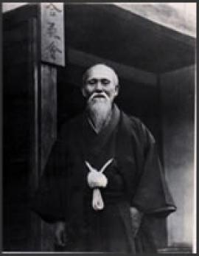
Ueshiba sensei
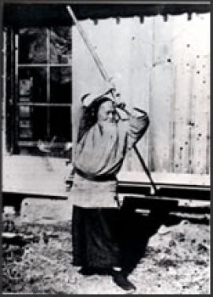
Weapons used according to Aiki laws.

The birth of Aikido
All students testimonies are unanimous. From 1942 and for more than twenty years, O sensei immerses himself in Aikido practice and study with an exceptional determination. He sets two axis for it:
- the constant improvement of empty hands techniques still rough or imperfect ;
- the correlation of the entire technical aspect of Aikido with a vast initiation-purposed symbolism.
With these two goals in mind, he developed like never before the use of the staff and the sword, studying every morning for hours the infinite possibilities of these weapons used according to aiki laws. These weapons act as a magnifier, enlarging fundamental principles less perceptible with empty hands.
To be fully acceptable, these last statements would need a technical back up for which there is unfortunately no space here. What must be remembered here is that O sensei achieved a colossal work in Iwama, between the age of 60 and 80 years old: he actually created Aikido in the sense that he organized it for the first time in a meaningful and structured whole, something the previous combat method didn’t have.
That gigantic task went nearly unnoticed in Aikido history. The explanation is both simple and hard to be conceived: There was barely anyone with the Founder all along these years. Only four true uchi-deshi lived in Aiki Shu Ren dojo:
- Kisshomaru Ueshiba, O Sensei's son, but he settled in Tokyo as early as the beginning of the forties and worked at Osaka Shoken company before taking responsibility of Aikikai's administration and the technical supervision of Ushigome dojo which would become Hombu dojo in 1956 only, mainly to promote Aikido's expansion world wide ;
- Koichi Tohei left Iwama around the same time to set up a coal business before settling in Hawai ;
- Tadashi Abe whom France was greatly honored to welcome in the early fifties ;
- Gozo Shioda who stayed only a short while in Iwama before founding his own school, the Yoshinkan, just after the war.
From 1950, there was no uchi deshi left in Iwama. This is important because O sensei taught tai jutsu every night to the local soto deshi and the occasional uchi deshi from Tokyo. But he practiced weapons in the morning in the surrounding countryside and nowhere else. No uchi deshi shared his work anymore.
We have to understand this astonishing situation:
Although he devoted the best part of his research to weapons, O sensei did not and would never teach them. He even ended up forbidding their use in Tokyo’s Hombu dojo where, in rare occasions, he only showed a few possibilities of the staff and the sword.
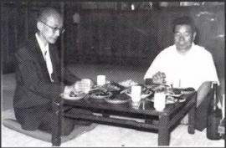
Kisshomaru Ueshiba & Morihiro Saito

The randomness of history
However, during his daily morning weapons trainings, O sensei was not completely alone. Even if all uchi deshi had gone away, he had one partner left: a soto deshi, a local from Iwama, enrolled in 1946 and who was able to live one day on two with the Founder since he worked at the Japanese Railways on a peculiar schedule.
Thanks to a great accident of history, Saito sensei had thus been the only witness to play an active role in O sensei's constant work and research with weapons. This was how, between 1946 and 1969, he learned what nobody else was destined to learn from the Founder. Without that historical "accident" the priceless universe of Aikido weapons that O sensei spent so much time and effort exploring would now be closed forever.
This is probably to seal that mission - for the future of Aikido - that O sensei made him the guardian of the historical Iwama dojo he had loved so much and the Aiki Ginga, the temple of Aikido, built next to it. it.

Technique Examples

Ikkyo
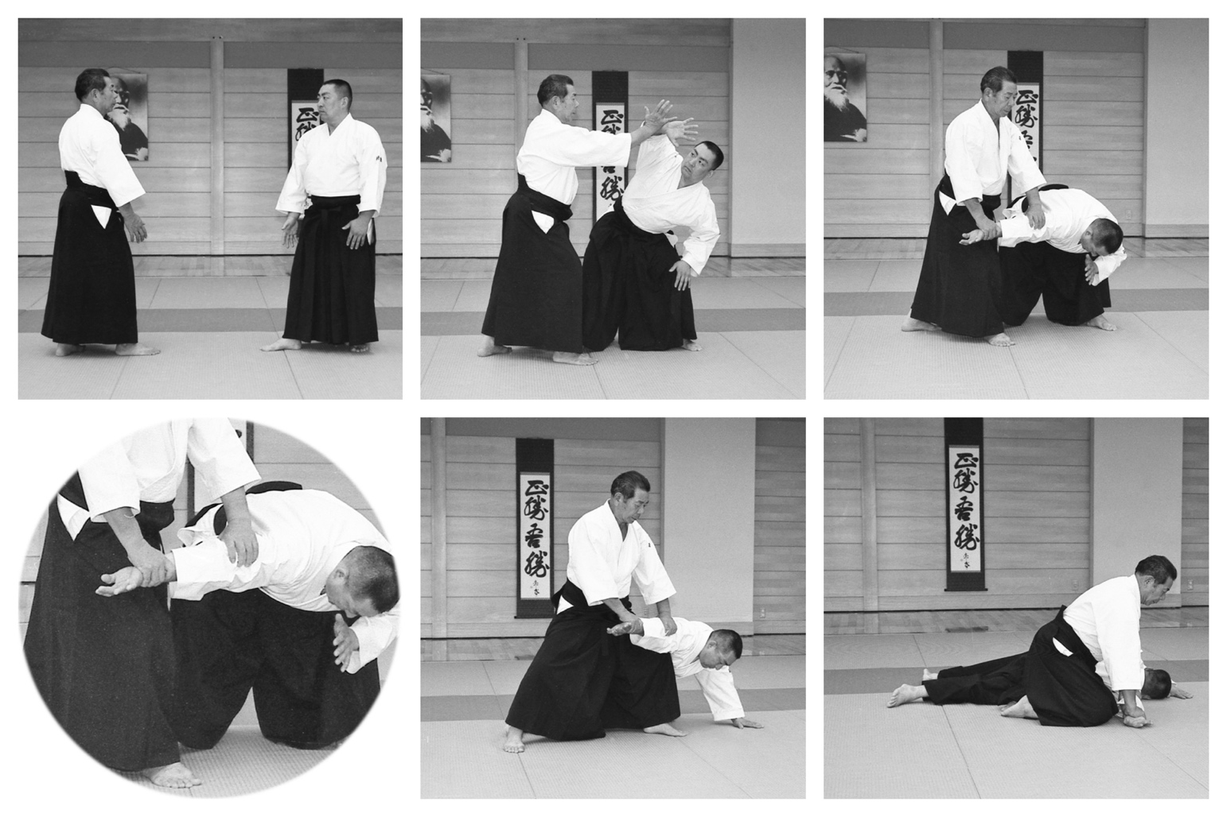

NIKKYO

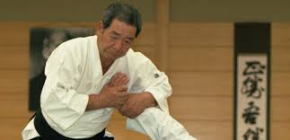

Sankyo

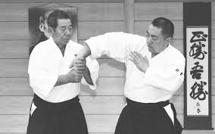

YONKYO
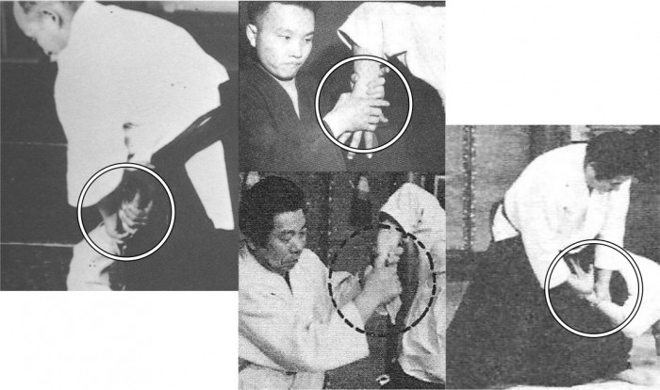

GOKYO
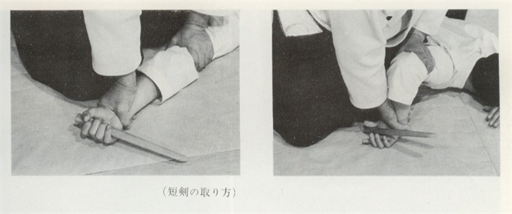

SHIHONAGE
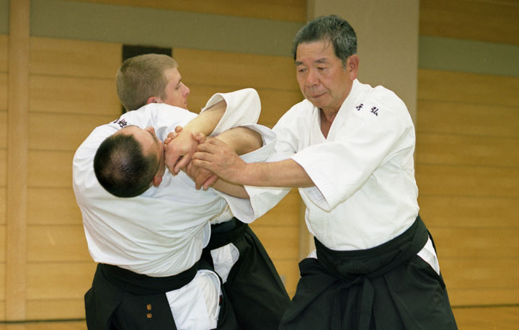

Kotegaeshi
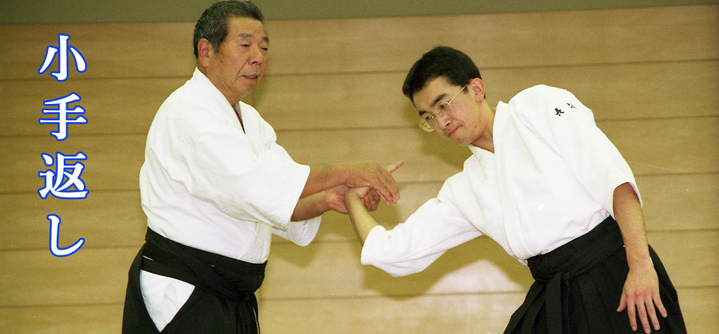

Iriminage

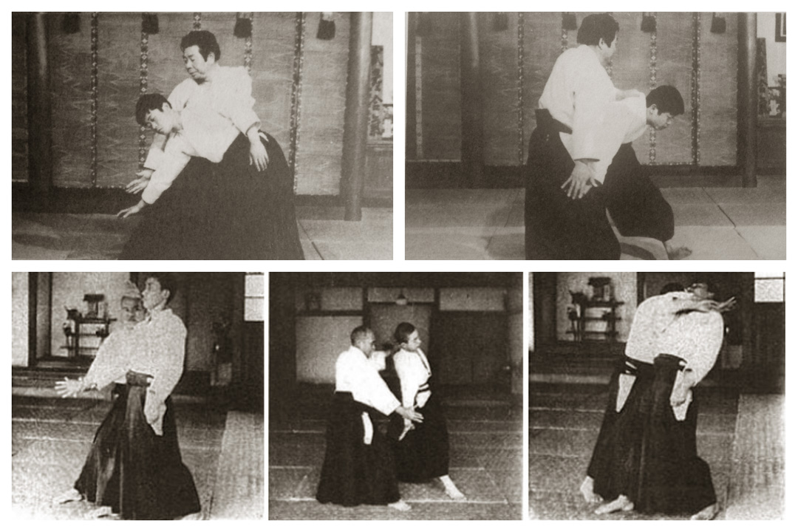

Kaitenage
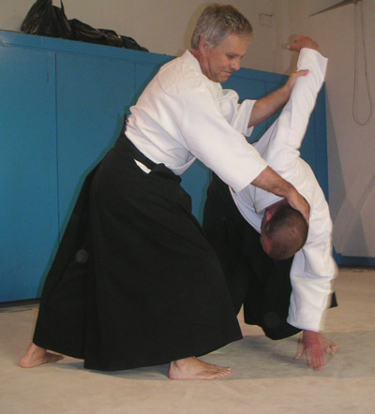

Kokyunage
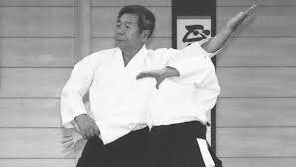

KOSHINAGE
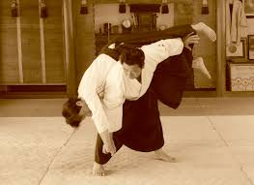

http://www.aikidotakemusu.org/en/articles/iwama-ueshiba-senseis-last-adventure

